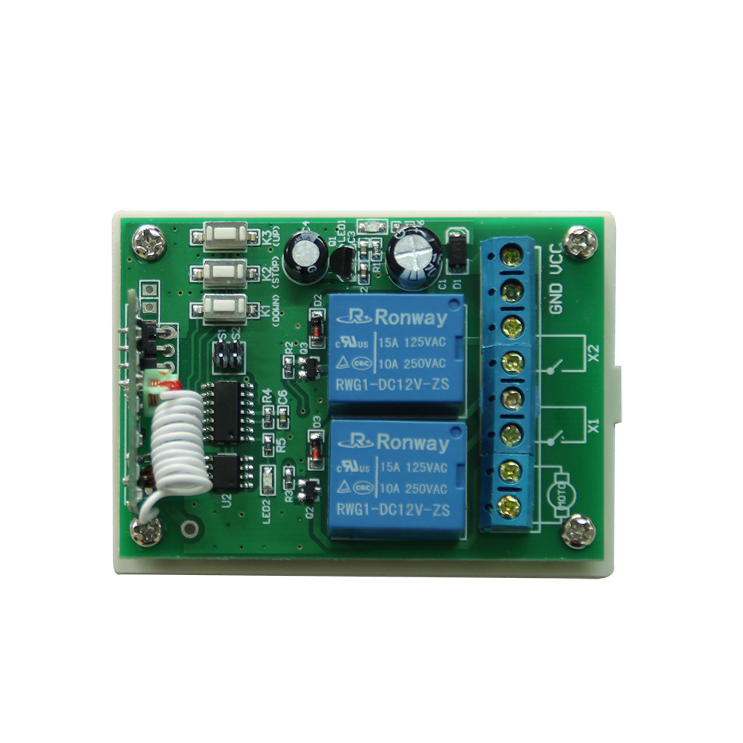
Limit Switch 2 (normally close type)
Limit Switch 1 (normally close type)

DC Power Supply

DC MOTOR

+

-

